SARDAR VALLABHBHAI NATIONAL INSTITUTE OF TECHNOLOGY, SURAT
DEPARTMENT OF CIVIL ENGINEERING
Advanced Hydraulic Laboratory
The Advanced Hydraulic Laboratory is developed under the Centre of Excellence on “Water Resources and Flood Management” in the Department of Civil Engineering. 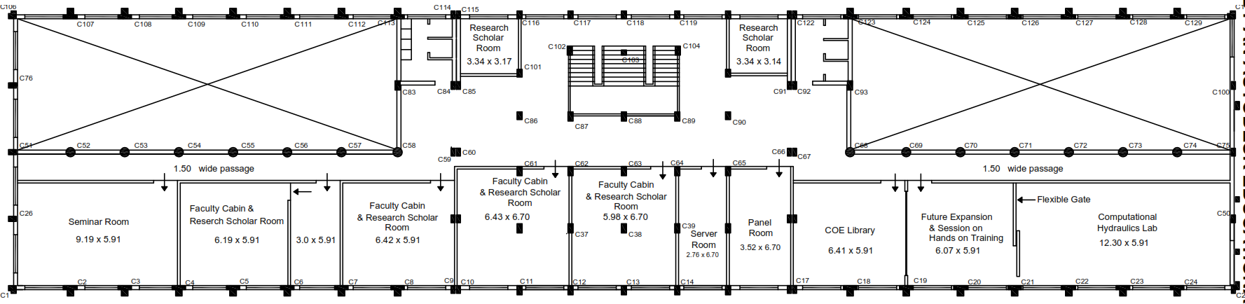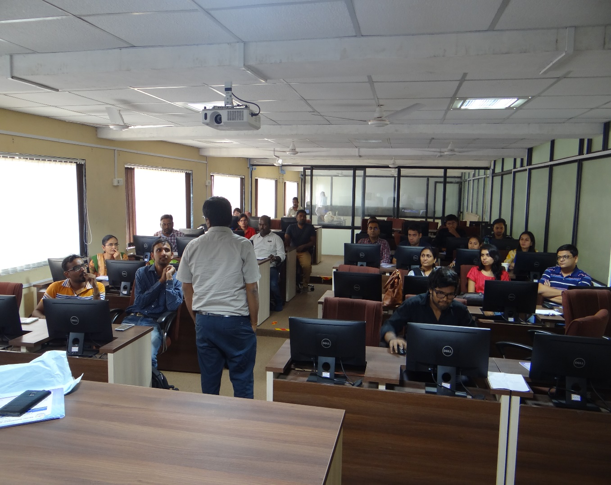

Following facility/equipment are available in the Advanced Hydraulic Laboratory:
Equipment Name | Equipment Details
Recirculating Water Distribution System | Pumping and water circulation system operated through SCADA for  a) Flow Calibration facility  b) Recirculating sediment Transport flume  c) River Tray
Laser Doppler Velocity Meter (LDV) | 3 – Axis Traverse System, 600 X 600 X 600 mm, includes mounting base, 3 – axis controller compatible with supplied LDV software. Single probe LDV Mount Kit, including mount and rotation plate for attaching a single 5 – beam transceiver probe to a 90X90 mm rail. Single Rail Hardware Kit, includes endcaps and feet for a single 90X90 mm rail. 90X90mm Rail, 1.0 m long.  1) External Water Chiller  2) Step Down Transformer
Ultra Sonic Level Transmitter (Nos. 32) | NIT-INDIV --- 32 individual 5 MHz transducers. Transducers housed in stainless steel 0.5 inch in diameter, 1.0 inch in height.  NIT- ELECT --- Electronics for ultrasonic ranging system. Includes all required electronics to run the microprocessor controlled transducers described above as well as a data logging system.
Acoustic Doppler Velocimetry (ADV) | 16 MHz Acoustic Doppler Velocimeter. Acoustic Sensor: 3D, Three – axis velocity measurement. Sampling rate: 0.1 to 50 Hz. Sampling Volume: less than 0.09 CC. Dist. To sampling volume: 5 cm. Resolution: 0.01 cm/s. Prog. Velocity range $±$3 to $±$250cm/s Should measure flow velocity from less than 1 mm/s to over 2.5 m/s. Accuracy 1% of measured velocity, 0.25 cm/s. Maximum depth rating : 6 m
Sieve Shaker | Motorized with Built-in Digital Timer and Adaptor for 30 cm and 20 cm dia. sieves.
Electro-magnetic Flowmeter | External flow measurement device to measure flow up to 500 LPS capacity in closed conduit pressurized flow.
Recirculating Sediment Transport flume | Recirculating Sediment Transport flume  16 m long, 0.9 m wide, 0.6 m depth  (75 LPS flow capacity)
River Tray | River Tray  24 m long, 3 m wide, 1.15 m depth with 200 LPS flow capacity
Vectrino-Profiler | 3D – Profiling Velocimeter, including firmware with 4 beam down looking profiler probe, probe mounted on 36 – cm fixed stem, Housing with 12 – pin underwater connectors, 10 cm cable with 12 in underwater connector including RS 485 to USB converter, Transportation and storage case.  200 Hz data capturing capacity.
Electronic Weighting Scale | Electronic weighting scale having load capacity 15 kg.
GNSS | Trimble Integrated Receiver Antenna Receiver for Global Navigation Satellite System (GNSS) with Memory stick (Trimble R12LT)  Trimble Storage Controller for Global Navigation Satellite System (Trimble TSC3 Controller)

The laboratory is main developed through the external research funding. The laboratory is main utilized for PG and PhD research work.
Few of the photograph of the laboratory is shown below:
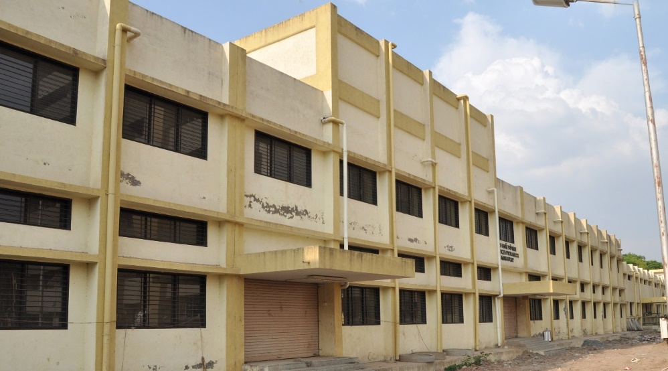 | 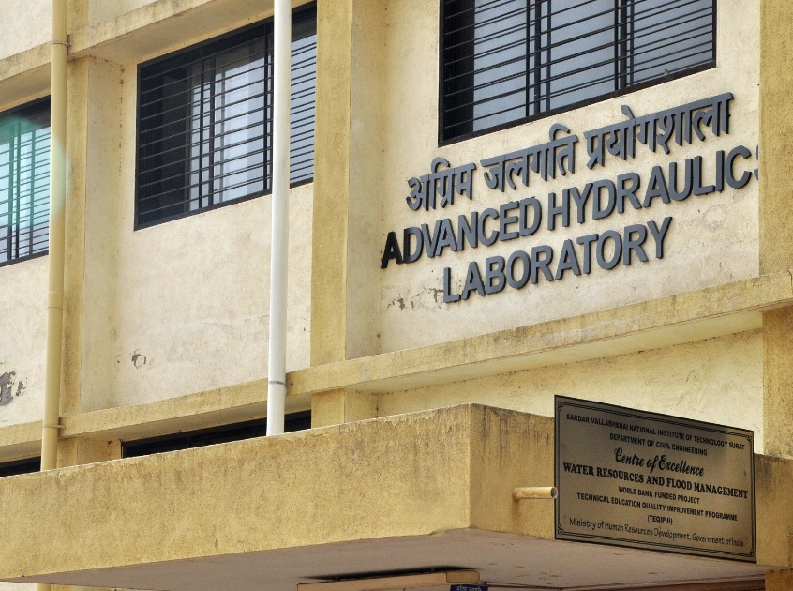

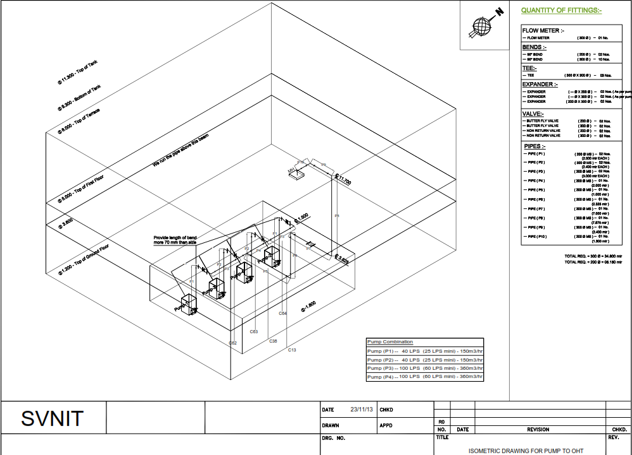
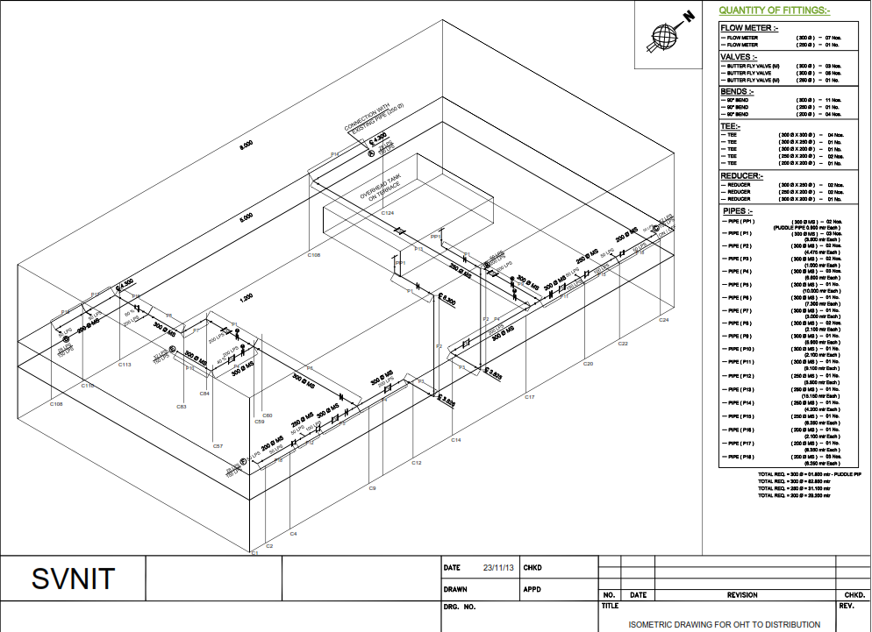

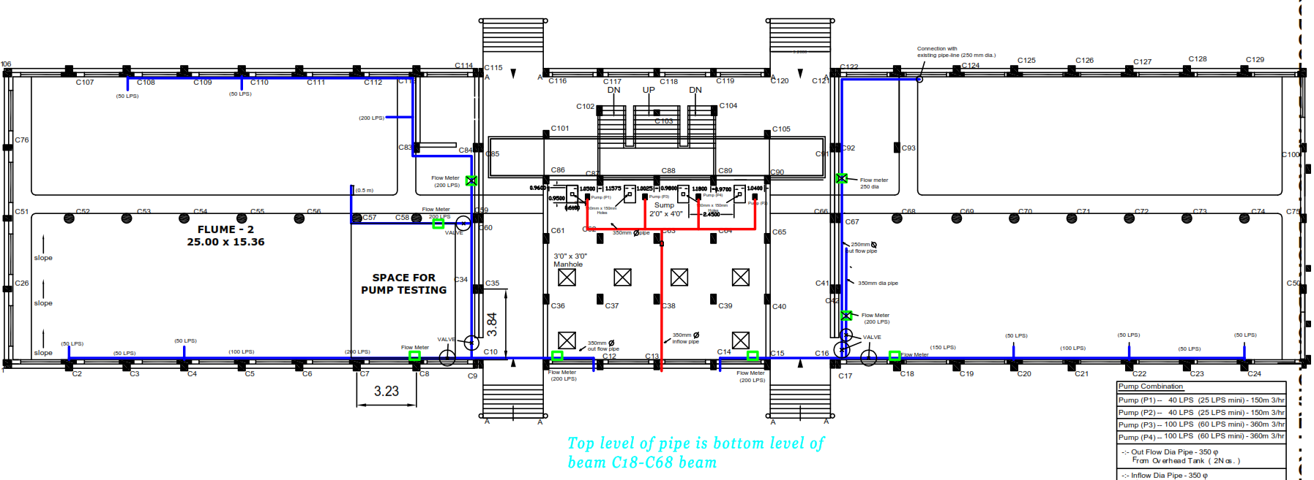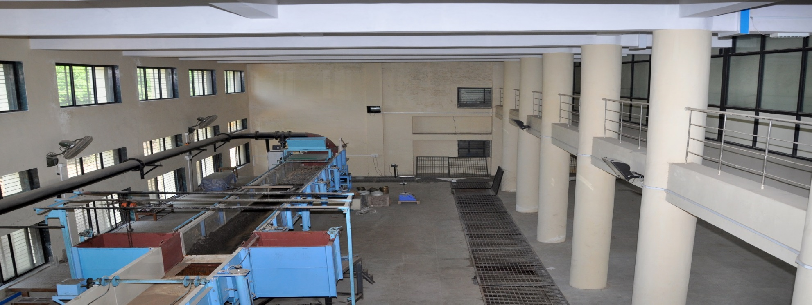

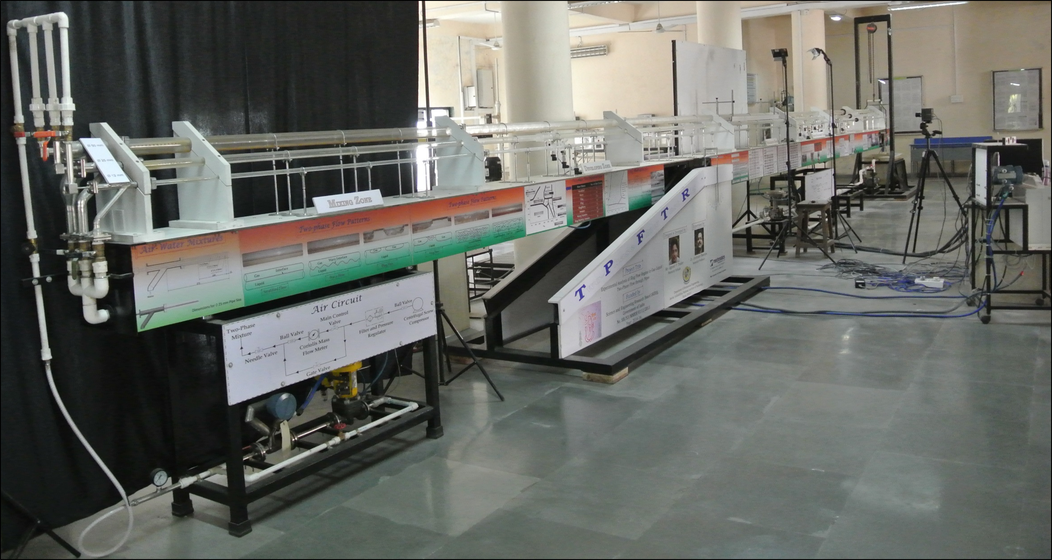
Developed Experimental Flow Facility for Two-Phase Flow Measurement where the Laser Doppler Velocimeter is used.

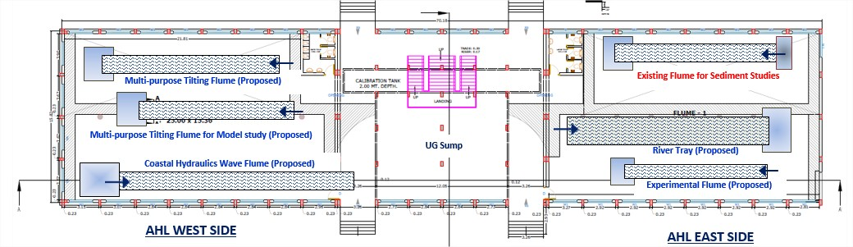
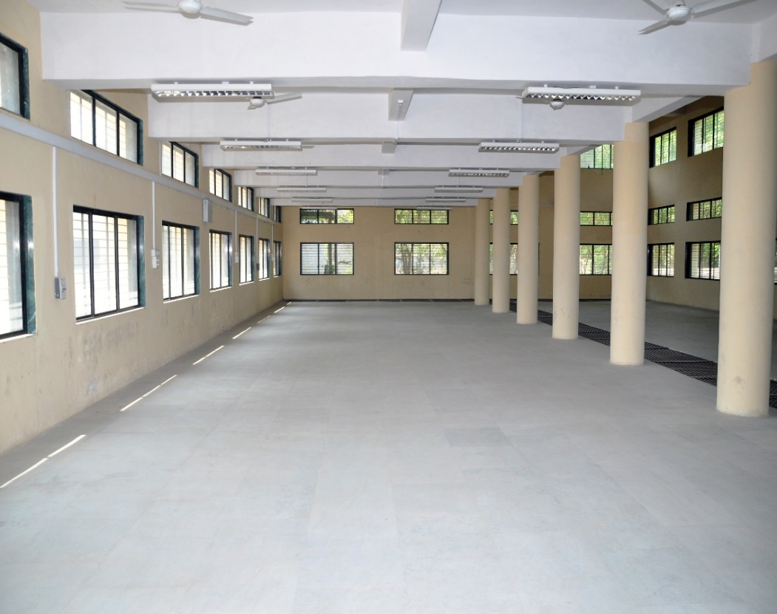
Proposed space for DST FIST project Flume
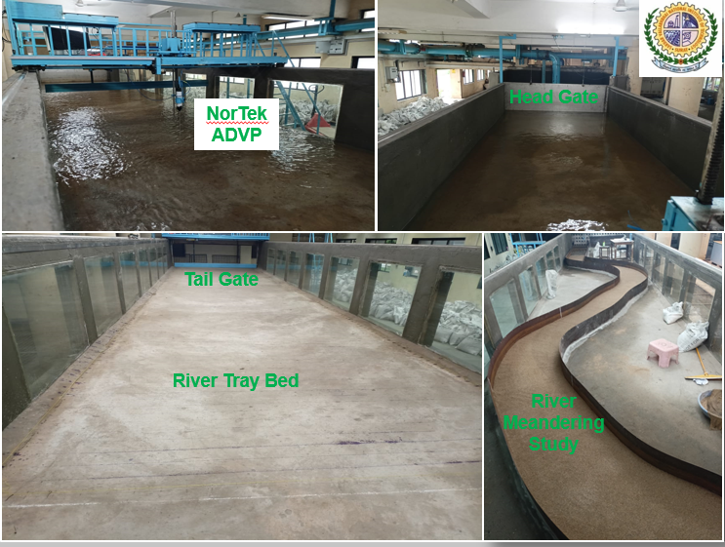
River Tray Facility

